# Reigning Weightlifting Champions (Corrected)

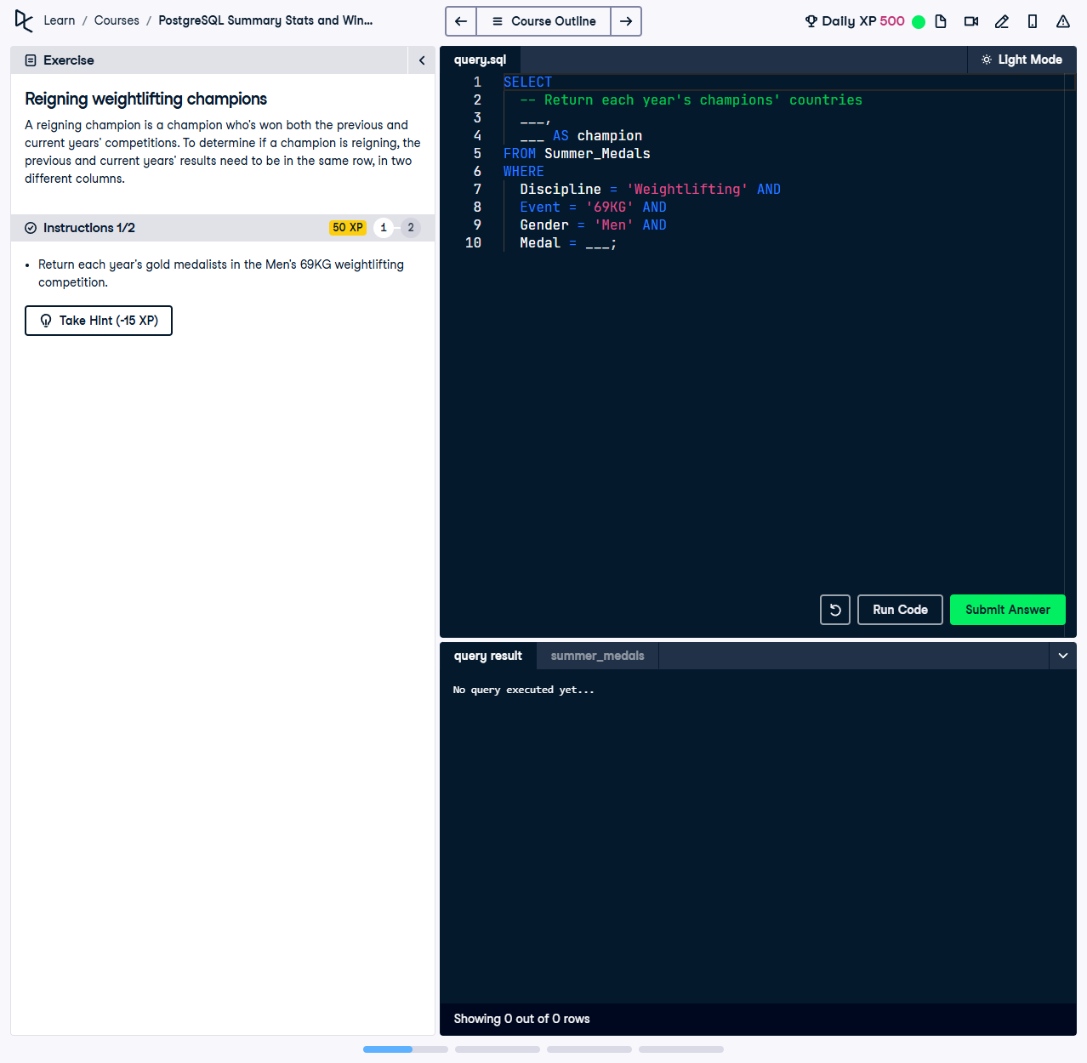

A reigning champion is a champion who’s won both the previous and current year’s competitions. To determine if a champion is reigning, the previous and current years’ results need to be in the same row, in two different columns.

This exercise involves identifying reigning champions in the Men’s 69KG weightlifting competition by comparing results for each year to determine if the same athlete won gold in both the previous and current year.

## Correct Answer

SELECT  
 Year,  
 Country AS Champion  
FROM Summer_Medals  
WHERE  
 Discipline = 'Weightlifting' AND  
 Event = '69KG' AND  
 Gender = 'Men' AND  
 Medal = 'Gold';

Explanation of the query:

1. `SELECT Year, Country AS Champion`: Retrieves the year and the country of the gold medalist in the Men's 69KG weightlifting event. The column `Country` is renamed to `Champion` for better readability.

2. `FROM Summer_Medals`: Specifies the source dataset containing results of Olympic events.

3. `WHERE` Clause: Filters the dataset to ensure the query focuses on:

- **`Discipline = 'Weightlifting'`:** Includes only weightlifting events.

- **`Event = '69KG'`:** Focuses on the Men's 69KG category.

- **`Gender = 'Men'`:** Restricts the results to the men's competition.

- **`Medal = 'Gold'`:** Selects only athletes who won gold medals.